# **Name: Abdurrahman Qureshi**

# **Roll No: 210451**

Practical No: 5

**1) Write a Program to Count the length of a String, to find the**

**position of String and to compare two Strings.**

**CODE:**

<?php  
  
function string_operations($string1, $string2)  
{  
 $length_of_string1 = strlen($string1);  
 echo "Length of String 1: $length_of_string1\n";  
  
 $position_of_word = strpos($string1, 'world');  
 if ($position_of_word !== false)  
 {  
 echo "Position of 'world' in String 1: $position_of_word\n";  
 }  
 else  
 {  
 echo "'world' not found in String 1\n";  
 }  
  
 $comparison_result = strcmp($string1, $string2);  
 if ($comparison_result == 0)  
 {  
 echo "String 1 and String 2 are equal\n";  
 }  
 elseif ($comparison_result < 0)  
 {  
 echo "String 1 is less than String 2\n";  
 }  
 else  
 {  
 echo "String 1 is greater than String 2\n";  
 }  
}  
$string1 = "Say my name";  
$string2 = "No";  
echo "String 1: " . $string1 . "\nString 2: " . $string2 . "\n\n";  
string_operations($string1, $string2);

**OUTPUT:**

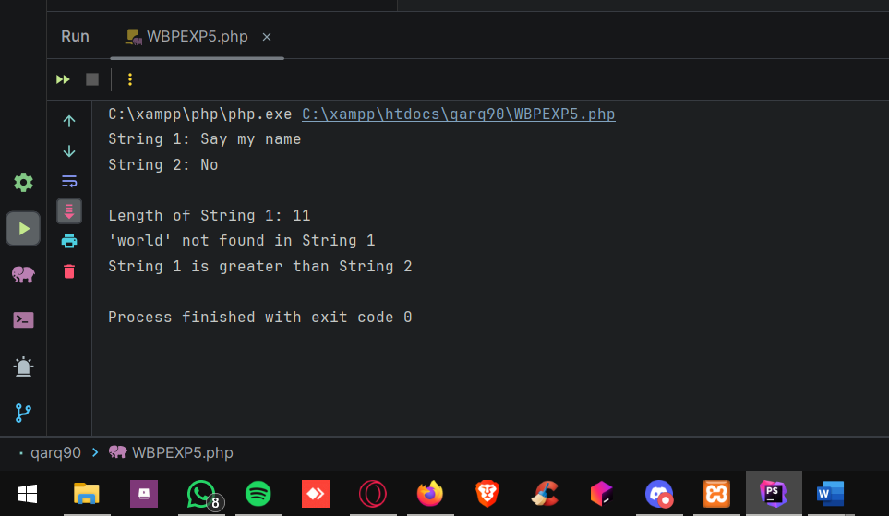

**2) Write a Program to Count the number of words in a String. (Execute for all return parameter values).**

**CODE:**

<?php  
echo "<h2>Count the Number of Words in a String</h2>";  
  
function count_words($input_string, $return)  
{  
 $word_count = str_word_count($input_string, $return);  
  
 echo "The string: '$input_string'\n";  
 print_r($word_count);  
 echo "\n";  
}  
$string1 = "Yo mistah white";  
$string2 = "PHP is a nalla scripting language";  
$string3 = "This is a message transmitted from the source codenamed bich";  
  
count_words($string1, 0);  
count_words($string2, 1);  
count_words($string3, 2);  
?>

**OUTPUT:**

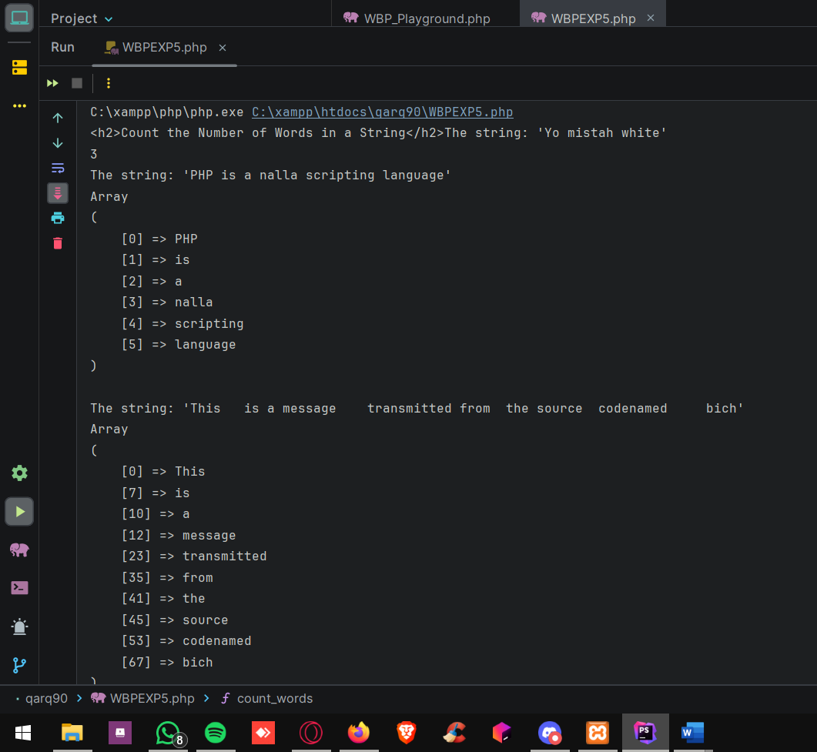

**3) Write a Program to reverse a string**

**CODE:**

<?php  
echo "Reverse a String";  
$test_string = "qarq90";  
$reversed_string = strrev($test_string);  
echo "Otiginal string: " . $test_string . "\n Reversed string: " . $reversed_string;  
?>

**OUTPUT:**

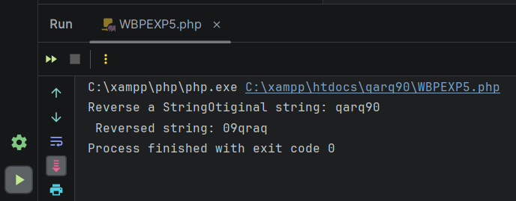

**4) Write a Program to Replace a String with the other String. Also count the number of replacements.**

**CODE:**

<?php  
  
$original_string = "The quick brown fox jumps over the lazy dog.";  
$search_string = "fox";  
$replace_string = "donkey";  
  
$replaced_string = str_replace($search_string, $replace_string, $original_string, $count);  
  
echo "Original String: $original_string \n";  
echo "Replaced String: $replaced_string \n";  
echo "Number of Replacements: $count \n";  
?>

**OUTPUT:**

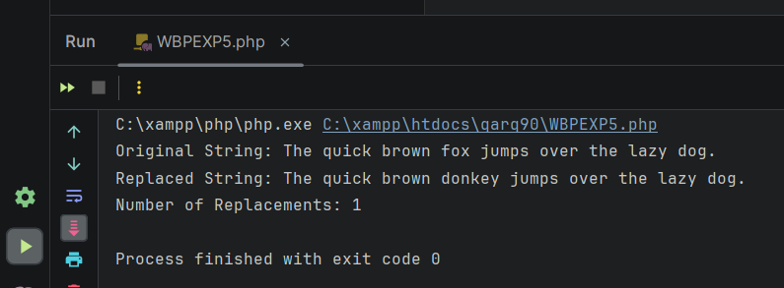

**5) Write a Program to convert the String to Uppercase, Lowercase, capitalize the first character of a string.**

**CODE:**

<?php  
$test_string = "Death is an old friend";  
echo "Original string: " . $test_string . " \n";  
$to_lower = strtolower($test_string);  
echo "String converted to lowercase: " . $to_lower . " \n";  
$to_upper = strtoupper($to_lower);  
echo "String converted to UPPERCASE: " . $to_upper . " \n";  
$first_character_capitalized = ucwords($test_string);  
echo "String where the first word has been capitalized: " . $first_character_capitalized;  
?>

**OUTPUT:**

